02 February 2026

ACCEPTANCE LETTER

Client: City of Tshwane

BID NO: HS 02 – 2025/26

Dear Sir/Madam

On behalf of SITHEMBE TRANSPORTATION AND PROJECTS, I hereby accept the appointment letter dated 27 January 2026, for the tender: TENDER FOR THE APPOINTMENT OF SERVICE PROVIDERS FOR HIRING, SERVICING, DELIVERY AND RE-LOCATION OF CHEMICAL TOILETS FOR A PERIOD OF THREE (3) YEARS, ON AN AS-AND-WHEN REQUIRED BASIS, WITH EFFECT FROM EFFECTIVE DATE.

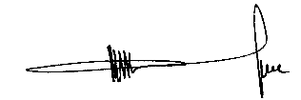
……………………………………………
MR. M.V LUKHELE
Director

